Competing dynamics: Analyzing market share in a duopoly
Osvaldo Diaz–Rodriguez *
Tai Nguyen †
Michigan State University
Department of Mathematics
East Lansing
MI 48824
U.S.A.
Hyejin Kim §
University of Michigan-Dearborn
Department of Mathematics and Statistics
Dearborn
MI 48128
U.S.A.
Tsventanka Sendova ‡
Michigan State University
Department of Mathematics
East Lansing
MI 48824
U.S.A.

Abstract
One of the main measures of success in business is a company’s market share, and understanding the cause and effect of various economic factors on market share is very important in the success of a company. In this paper we study market shares between two manufacturers in a duopoly economy. An optimal pricing strategy for a company to achieve the most market share in a duopoly economy is proposed. Two numerical models, based on ordinary differential equations, for the market share are developed to study the company’s success in the market. One model considers the quantity demand and investment in research and development, while the other model focuses on a more realistic relationship between the quantit y demand and the price.
This research was conducted during the NREUP at Michigan State University and it was sponsored by NSF grants DMS-1156582 and DMS-1359016.
Subject Classification: Primary 93A30, Secondary 49K15
Keywords: Mathematical Modeling, Ordinary Differential Equations, A duopoly economy, Market share

1. Introduction
It is often observed that a specific industry is dominated by two major competitors. For example, Boeing and Airbus share the majority of aircraft market. The PC processor market is divided in two by Intel and AMD. The smart phone industry is mainly occupied by Apple (iOS) and Android (Google). As duopoly markets occur frequently in the economy, it is important to understand the response of a duopoly to various factors such as price change and quantity demand.
Traditionally, the duopoly market has been modeled either by Cournot model or by Bertrand model in economics ([9, 2]). In the Cournot duopoly, competition between the two companies is based on the quantity of products supplied and the assumption is that each company decides the amount of output produced independently of and simultaneously with its competitor. While Cournot’s model assumes that the competitor produces the same amount of the output every time, Bertrand’s duopoly model assumes that each company determines the price of the product under the hypothesis that the competitor’s price remains constant. On the basis of the Cournot’s duopoly model, Cournot has concluded that each company will eventually reach the equilibrium position, where each of the two companies supplies one-third of the market, while one-third of the market remains un-supplied. Under Bertrand’s model, a Nash equilibrium is reached.
In this research, models for predicting the market share in a duopoly market are mathematically derived using ordinary differential equations, instead of a game theoretic approach. It is assumed herein that two companies completely dominate the market, that is, the sum of two competing companies’ market share is 1. The models are developed based on work by Matthew Spiegel and Heather Tookes [8], and Jehoshua Eliashberg and Rabikar Chatterjee [4]. The competition is modeled by ordinary differential equations based on a variant of the Lanchester (1916) battle model, which was originally designed to study military strategy (see [5]). We study the effects of quantity demand (QD), research and development (R&D), and price on the market share for each company.
The paper is organized as follows. In section 2, we construct and analyze a simple mathematical model including the effect of constant quantity demand. Section 3 discusses a general competing dynamics that study the effect of quantity demand and research and development. Section 4 provides numerical analysis of a more sophisticated model, which assumes that the relationship between quantity demand and price follows the Gaussian Distribution. Finally, in section 5 we draw conclusions and consider future work.
2. Simple Model Including Quantity Demand
We consider two competing companies. Let A(t) be the market share of company A at time t and B(t) be the market share of company B at time t. Let us assume that the two competing companies share the whole market, i.e., at any time t,
A(t) + B(t) = 1. (1)
First, we construct the simplest market share model that only includes the quantity demand effect into consideration.
A¢(t) = –bA(t) + aB(t), (2)
B¢(t) = –dB(t) + g A(t). (3)
Here b, g represent the quantity demand of firm B, and a, d represent the quantity demand of firm A. In (2), the –bA(t) term represents how the quantity demand of firm B affects firm A. For example, if the quantity demand of firm B is really high, that is, b is large, then the loss in market share of firm A will be relatively high. The second term a B(t) represents how much firm A increases its market share by attracting the competitor’s customers. The terms in the right hand side of (3) have an analogous interpretation.
Note that the market share of one company depends on the market share of the other company, that is, B(t) = 1 – A(t). Also, due to the fact that B¢(t) = –A¢(t), the parameters satisfy g = b and d = a, and it is enough to analyze only one company to obtain the information of market share for both companies. We assume all parameters are constants for simplicity. By substituting B(t) = 1 – A(t) into the equation (2), one arrives at
A¢(t) = –A(t) (a + b) + a. (4)
We can find the (stable) equilibrium point for the market share of two competing companies no matter what initial market shares are. This model is rather unrealistic under our assumptions, but it will be a base model for more sophisticated ones, considered in Section 4.
3. Quadratic Model
Next, we consider the effect of the quantity demand (QD) and research and development (R&D) on two competing manufacturers in a duopoly economy. Let a and b be constants, representing the QD of company A and B, respectively. We assume that the amount a company invests into R&D is directly proportional to the company’s market share. Thus, if r_{A} and r_{B} represent the research and development investment of companies A and B, respectively, we assume
(5)
where positive constants l_{A} and l_{B} are ratios of the research and development investment to market share of company A and B respectively.
As in Section 2, the equation governing the market share of company A is given by
(6)
After substituting (5) and B(t) = 1 – A(t) into (6), we get
(7)
As a result, the rate of market share’s change of company A involves a quadratic term of market share which will result in possibly 2 different equilibria.
3.1 Analysis of Quadratic Model
In general, model (7) could have at most two possible equilibrium points given by
(8)
where a, b, l_{A}, l_{B} are all positive real numbers.
Lemma 1: For every t ³ 0, there exists a unique equilibrium point in [0, 1] for model (7) given by
(9)
Proof: The assume that l_{B} < l_{A}. Then
(10)
Now let us assume, by way of contradiction, that A_{eq} > 1. Then we arrive at b < 0 which contradicts the assump tion that b is a positive real number. Thus A_{eq} must be less than or equal to 1. Due to our assumption, we can easily see that the other possible equilibrium point satisfies
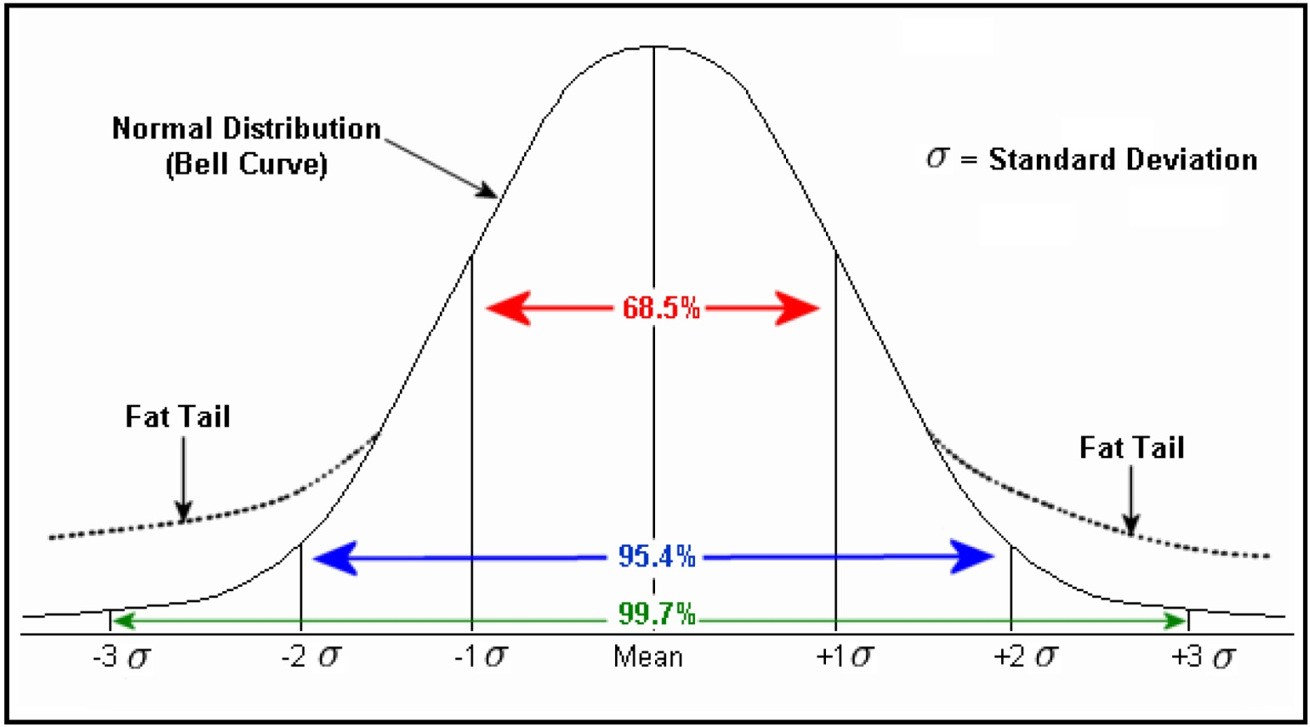
Figure 1
Gaussian Gaussian Distribution Curve

because Therefore A_{eq} is the only equilibrium point which lies in between 0 and 1 under the assumption of l_{B} < l_{A}.
Next, assume that l_{B} > l_{A}. Similarly, by using proof by contradiction, it is easy to check 0 £ A_{eq} £ 1. As above, one shows that the other possible equilibrium point is less than or equal to 1, it implies b £ 0 which is a contradiction. Therefore, (9) is the only equilibrium point in [0, 1].
From Lemma 1, note that the unique equilibrium point is always stable because A¢(t) > 0 if A(t) < A_{eq}, while A¢(t) < 0 for A(t) < A_{eq}. From here one can automatically compute the equilibrium market share for the company B:
4. Quantity Demand of a Gaussian Distribution
In this section we introduce a model, which incorporates a more intricate relationship between quantity demand and price. Here we focus on the effect of QD and thus ignore R&D for simplicity. This model will only cover a short period of time, and it is based on the following assumptions: all products in the market must have the same quality, and the sum of the quantity market share for both manufacturers is 100%. We assume that the quantity demand and price are directly proportional to the quantity of the market share. Additionally, we assume that the relationship for the quantity demand and price follows the Gaussian distribution as in Fig.1.
Using the same notation as in model (4), let the quantity demand a and b of companies A and B respectively, be given by:
(11)
Here m represents the mean value price (average price) for the product in the market, s represents standard deviation, and P_{A}, P_{B} represent the price in terms of market share for manufactures A and B, respectively. Since a manufacturer always wants to make more profit, the company increases the price as the quantity of market share increases. Thus, we assume that the price is directly proportional to the quantity of market share in a short period of time. So we have the following model:
(12)
where
(13)
Here k, j represent the increasing rate of change in the price for manufacturers A and B, respectively, and p₀ represents the initial price, which is a given constant. To be fair, we set a price floor p₀ for both manufacturers to be the same, which prevents both manufacturers from selling their product at a price lower than p₀.
4.1 Analysis
Model (12) is a composite function between exponential function and polynomial function, and finding the equilibrium points becomes non-trivial. To make the calculation tractable, we simplify the model by using the Taylor Expansion for the exponetial terms up to second order of (P_{A} – m) and (P_{B} – m) and truncate higher orders.
(14)
Substituting (14) back into our model (12) we arrive at
(15)
Since two standard deviations covers about 95.44% of the case (see Fig. 1), it is reasonable to set the price floor p₀ = m – 2s in (13). This yields,

Since our focus is to determine the pricing strategy for one company, let us introduce the ratio k/j = r. Thus
(16)
We substitute the price function in terms of market share (16) back into equation (15). We arrive at the following equation which describes two competing dynamics with the quantity demand of a gaussian distribution:

(17)
The the right hand side of (17) involves a third degree polynomial in terms of A(t). By the Intermediate Value Theorem, there must be exist at least one equilibrium point of model (17) in [0, 1], because when A(t) = 0, while it is easy to show A¢(t) > 0 when A(t) = 1, and A¢(t) is continuous. In the next subsection we numerically study the stable and unstable equilibrium points under different scenarios.
4.1.1 Numerical Analysis
A parametric study of model (17) was performed using Mathematica. To examine the effect of different pricing strategies, company A was given a more aggressive pricing strategy, represented by r. The variable r is the ratio of the rate of change of the price for manufacturer A over the rate of change of the price for manufacturer B, and for company A it is set strictly greater than 1.
First, let us consider the most trivial occurrence with only one equilibrium point. The single equilibrium point is always an unstable equilibrium point, because in model (17) the rate of change of market share A is negative when A(t) = 0 and the rate of change of market share A is always positive at A(t) = 1. This means that for a manufacturer whose initial market share is less than the equilibrium point, its market share will converge to zero, while if the market share is greater than the equilibrium value, the maker share will converge to 1. In other words, a manufacturer either achieves monopoly or drops out from the market, and it is virtually impossible for both manufacturers to share the market in this situation. In addition, if there exist even two distinct equilibrium points in model (17), one of which is a double root, only one manufacturer could survive in the competition depending on its initial market share.
The effect of different rates of price increase is modeled, and the results are shown in Figure 2. The rate of price increase for company B is denoted by j. Company A is assumed to be aggressive in maximizing its revenue, and the price increase rate is higher than that of company B by factor of r (that is, the rate of price increase for company A is j × r). The relationship between j and r can be further studied from Figure 2 and Figure 3, where several different sets of values (j, r) are compared.
In Figure 2(A), we assume that company B is increasing the price at a rate of $2 per week. If the marketshare of company A is larger than 40%, company A can eradicate company B by increasing the price at a higher rate of $2.42 per week. On the other hand, if the market share is less than 40%, company A will self-destruct by having the same rate of price increase. This shows that when the market share is large enough, one can control the market to remove the competitor by having a higher price increase rate. However, the same strategy will adversely affect the market share if the initial market share is not strong enough. It is important to have a certain market share beyond a threshold value for a company A to survive in the market. Until it reaches the threshold value, company A should keep the ratio r as low as possible and aim for the highest possible market share. This is because as the ratio between the rate of change of the price for manufacturer A over manufacturer B increases, the highest possible market share for manufacturer A decreases. However, company A could only decrease the ratio down to a certain value based on its own current market share, because the unstable equilibrium point of market share also increases as the ratio r decreases. (See Figure 2(B) and Figure 3(A))
Next, let us consider the case when model (17) has three equilibrium points.
In Figure 3(A), the ratio between the rate of change of the price for manufacturer A over the rate of change of the price for manufacturer B varies, while manufacturer B is selling their products at the same rate of price change based on the market share. We can see that as manufacturer A increases the price of their product, their market share decreases unless the initial market share of firm A is too low or too high. For example, let us look at a red dotted curve with parameters (j, r) = (4, 2.25) and the solid blue curve with (j, r) = (4, 1.5). These two curves show that manufacturer B’s rate of change of the price is held constant, while manufacturer A’s rate of change of the price increases from 6 to 9. Under this condition, the stable equilibrium point, which represents the highest market share, shifts to the left, and the highest market share decreases. This happens because the customers are reluctant to buy more expensive merchandise while there are cheaper alternatives.
Now, consider Figure 3(B). Manufacturer A increases or decreases the price of their product depending on the competing manufacturer B’s price. Manufacturer A’s price strategy is to keep the same ratio between the two companies’ rates of change of the price so that the highest market share is barely changed even though the two companies’ prices keep changing. The equilibrium point virtually remains the same as long as the ratio is not changing, even if j is varied from 4 to 6. This tell us that regular customers do not easily change their purchasing habits if both manufacturers are similarly changing the price and there are no other options.
Lastly, by comparing the two plots in Figure 3, one can observe that the equilibrium point is highly sensitive to the ratio r. Therefore, no matter how fast manufacturer B increases their price, manufacturer A’s market share will bot be affected significantly as long as manufacturer A keeps the ratio constant.
5. Discussion and Conclusion
Mathematical models for predicting market share in a duopoly have been developed. One model considered the effect of the quantity demand and the research and development on the market share, while the other model considered only the quantity demand, but with an improved relationship with the price. The developed models were applied in case studies. The case studies revealed the importance of the initial market share, and the sensitivity of relative price increase rate between the companies on the market share. The observation agrees well with the commonly accepted economics models, which is encouraging.
One of the limitations of the current study is the lack of statistical data to validate the model. The data acquisition will not be a trivial task, but if one could find appropriate data, further analysis on the relationship between the price and the market share will be possible. In addition, there are more factors to market share than what was covered in the current study, such as the marketing strategy and distribution. Those effects will be considered in subsequent studies.
References
[1] Andrew Ainslie, Xavier Drze, and Fred Zufryden, Modeling movie life cycles and market share, Marketing Science 24.3, pp. 508–517, (2005).
[2] J. Bertrand, Book review of theorie mathematique de la richesse sociale and of recherches sur les principles mathematiques de la theorie des richesses, Journal de Savants 67 (1883).
[3] Lee G. Cooper and Masao Nakanishi, Market-share analysis: Evaluating competitive marketing effectiveness, Boston: Kluwer Academic Publishers, (1988).
[4] Jehoshua Eliashberg and Rabikar Chatterjee, Analytical models of competition with implications for marketing: issues, findings, and outlook, Journal of Marketing Research, pp. 237–261, (1985).
[5] Frederick W. Lanchester, Aircraft in Warfare: The Dawn of the Fourth Arm, Constable limited, (1916).
[6] N. Gregory Mankiw, Principles of microeconomics. Cengage Learning, (2014).
[7] Nirvikar Singh and Xavier Vives, Price and quantity competition in a differentiated duopoly, The RAND Journal of Economics, pp. 546–554, (1984).
[8] Mattew I. Spiegel and Heather Tookes, Dynamic competition, innovation and strategic financing, Innovation and Strategic Financing, (2008).
[9] Hal R. Varian, Intermediate Microeconomics: A Modern Approach, W.W. Norton & Company, (2006)

Received June, 2016

Information for Contributors
The language of the manuscript should be English only.
A research article should comprise of the title, author(s), affiliation of author(s) with email(s) and phone number(s), a sufficiently informative Abstract of about 100 words, AMS Subject classifications, Keywords and Introduction of the paper. ‘End of proof’ should be indicated by a halmos X. References at the end of the manuscript should be arranged alphabetically;
citation of reference in the text should be indicated by bracketed numbers, i.e., [1].

